Gleeson Clinic Massage/Matrix Repatterning Health History
1304 E. Victoria Ave., Thunder Bay, ON., P7C 1C2 Tamara Brady, RMT
Phone: (807) 623-5531 Fax: (807) 626-9511

Please complete this form to assist us in treating you safely and effectively. Feel free to ask any questions about the information being requested. All information is kept confidential. Your written consent is required before release of any personal or medical information unless required by law.
General Information:
Name: ________________________________________________ Date: ____________________
Address: ______________________________________________ Birth Date: _____________ Age: ____
City: _____________________ Province: ________ Postal Code: ___________
Preferred Phone: ________________ Emergency Contact: ___________________ Phone: ____________ Occupation: _____________________________ Have you had massage before?: ___________
How did you hear about our clinic? ____________________________________________________________
Referring Practitioner (if any) _________________________________________________________________
Language Preference: English Other: ____________ Accessibility/Mobility Needs:___________________
Please list reasons for seeking care:
Complaint |  | Since | Causes
1
2
3

Circle problem areas on diagram, past or present: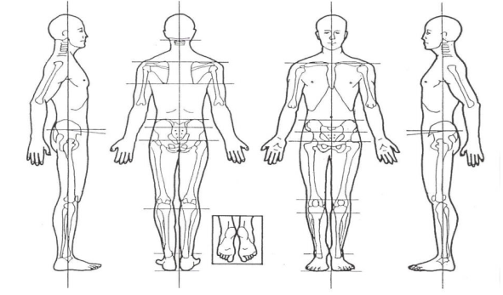

Please describe: (eg. stabbing, aching, dull, tight): ______________________________________________________________________________________
Does the discomfort travel to other areas?
______________________________________________________________________________________

Diagnostic tests (eg. Xray): ___________________________________________

Care for these areas with other practitioners? Explain:_______________________________________________________________________________

Do these complaints interfere with your sleep? Yes No. If yes, please explain: ____________________________________________________________________________________________
Do these interfere with your daily activities, work, exercise, sleep, hobbies? If yes, please explain: __________________________________________________________________________________________________________________________________________________________________________________________
How would you rate your stress level? (0-10): _ /10 General Health: poor fair good excellent
Medical History
Physician: ___________________ Address: _______________________________
Are you pregnant? ______ Due date? ___________________________________
Medications: Are you taking any blood thinners, or medications for blood pressure, pain…?:
Medication |  | Date started | What it treats
1
2
3
4

Please list any of the following that apply to you:
Allergies: (to lotions, medications, foods, environmental….)
___________________________________________________________________________________________

Accidents, Injuries, Falls, Surgeries or Implants (pacemaker, prosthesis, pins, etc,.) Include year: ___________________________________________________________________________________________
___________________________________________________________________________________________
___________________________________________________________________________________________

Hospitalizations or illnesses and the year: _______________________________________________________

Please check any condition that applies to you, past or present:

spasms or cramping
Where? ______________________
hernia
Where? ______________________
reflux / heartburn
herniated discs:
Which ones? __________________
scoliosis
numbness / tingling
Where? ______________________
arthritis: RA OA Where?:______________________
bone and joint pain
swelling (eg. gland, leg)
Where? ______________________
osteoporosis / osteopenia
diabetes: onset:_______________
hypoglycaemia
fatigue / poor endurance
ulcer
breast lumps / pain
kidney infections / stones
gallbladder problems
liver problems
nausea/vomiting
digestive problems (eg. constipation, diarrhea…)
Explain:______________________
bladder problems

Skin
bruise or bleed easily
skin conditions or sensitivities, eg. change in mole, open sores, rashes, warts, psoriasis, eczema, athlete’s foot… Explain:______________________ _____________________________

Head and neck
concussion or whiplash
When? ______________________
tension headaches
How often?___________________
migraines
How often?___________________
eye/ vision / nose / sinus / ear /
hearing problems:
What? ______________________
tooth / jaw / TMJ problems
tinnitus / sounds in ears
dizziness or vertigo
epilepsy
confusion
stroke / CVA / TIA?

Respiratory
difficult breathing
chronic cough
asthma
other conditions; eg. emphysema, bronchitis, TB,..
What?______________________
Cardiovascular
high blood pressure
low blood pressure
heart disease
heart attack / MI
heart palpitations / arrhythmias
chest pains / angina
varicose veins
aneurism, thrombosis, or clots
If yes, how long ago?___________
haemophilia

Other conditions / diagnoses past or present you may wish to share:
eg. fibromyalgia, AS, ALS, MS, Raynaud’s, IBS, endometriosis, fibroids, tumours, cancer, shingles, anxiety, depression, infections…: ________________________________________________________________________________________
________________________________________________________________________________________

I certify that the information given in this form is true and accurately reflects my past and
present health status. I will notify my Massage Therapist if there is any change in my condition and update records accordingly.

Client’s Signature ___________________________________________ Date ________________________

